Linux/Suricata Lab

Suricata is the name of the tool being executed. It's the command-line interface for the IDS/IPS engine.
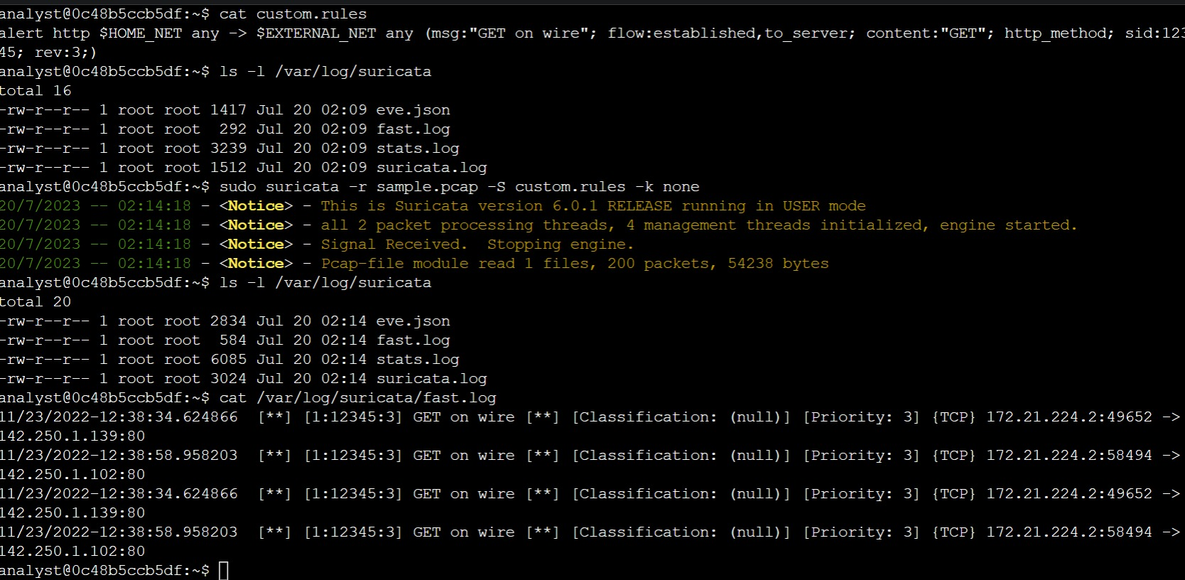
Steps

- List the files in the /var/log/suricata folder: ls -l /var/log/suricata
- Run suricata using the custom.rules and sample.pcap files: sudo suricata -r sample.pcap -S custom.rules -k none
- List the files in the /var/log/suricata folder again: ls -l /var/log/suricata
- Use the cat command to display the fast.log file generated by Suricata:
cat /var/log/suricata/fast.log

